Changing the View

- Open an internet browser and navigate to https://25live.collegenet.com/pro/uark .

- Click the More link.
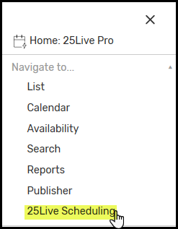

- Click 25Live Scheduling from the dropdown menu.

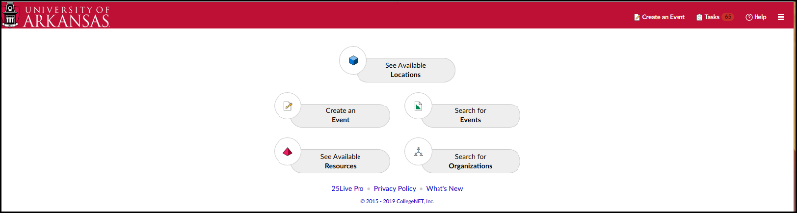
- Desktop and mobile views
are displayed.

- Click the button for area needed.

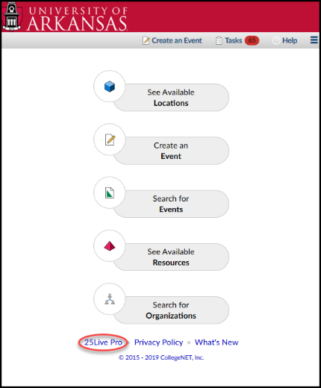
- If you are working on a desktop computer in
mobile view and want to return to the desktop
version, click the Desktop Version link at the
bottom of the screen.

