How Do I Change My R25 Password?

- Click Options in the top menu bar. The Options menu will display

- Click Change Password from the menu to create a personal password.

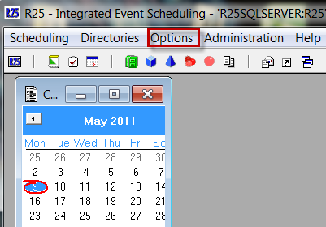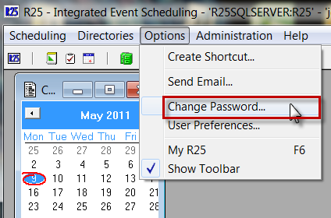

- Type in your current password in the Current R25 Password field. (Your current password is initially set to the login ID)

- Type your uark.edu email account password in the New Password field. Remember that passwords are case sensitive.

NOTE: Your password may be different from your uark.edu email account, but may easier to keep up with if it is the same as your email account.

- Confirm your uark.edu email password in the Confirmation field.

- Click OK to complete the password reset.

